General (104 Responses)

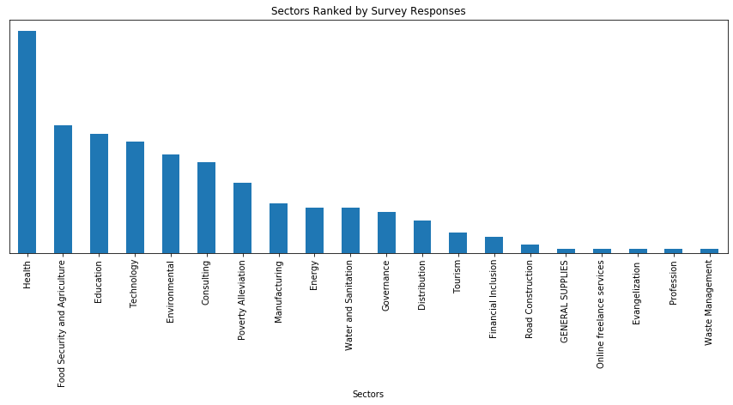

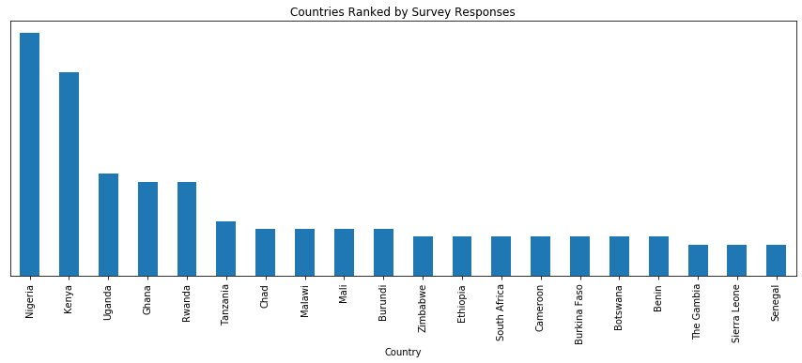

Question 1

From the list of challenges below, please select up to five challenges that you have experienced or observed to be most adversely affected (WORSENED) by COVID-19 in your African innovation ecosystem:

Nb (Includes Other)

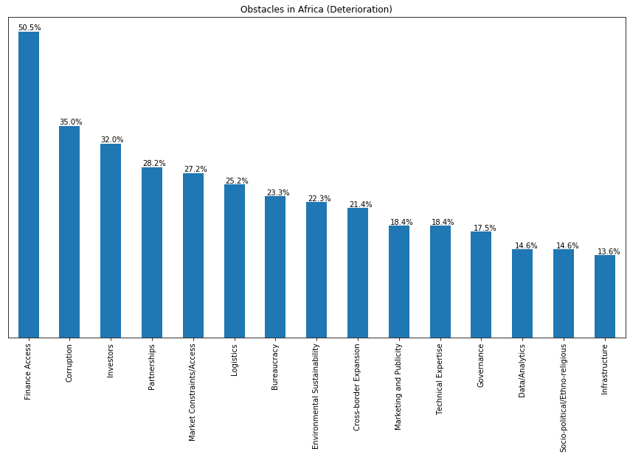

From the list of challenges below, please select up to five African innovation ecosystem challenges that you have experienced or observed to have IMPROVED during or due to the COVID-19 pandemic response:

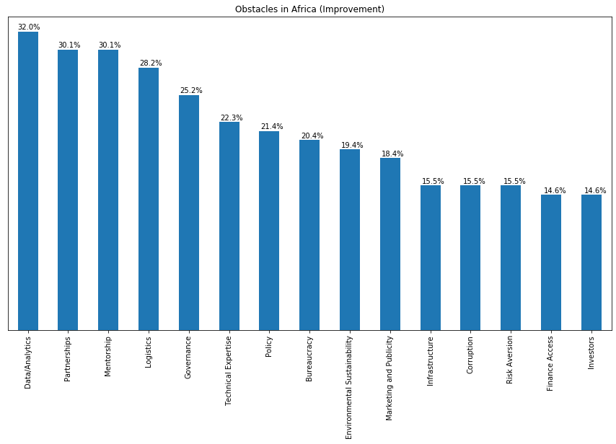

Please list and briefly describe your challenges / issues that have been the worst affected by the COVID-19 pandemic

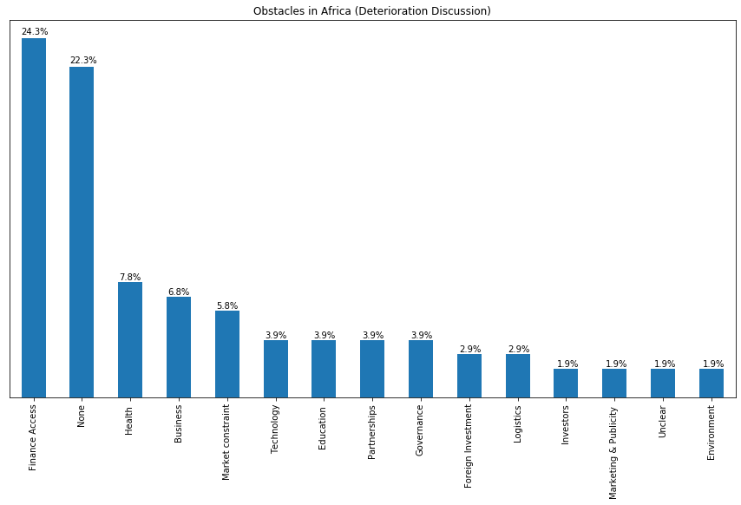

Please list and briefly describe your challenges / issues that have improved the most due to responses to the COVID-19 pandemic

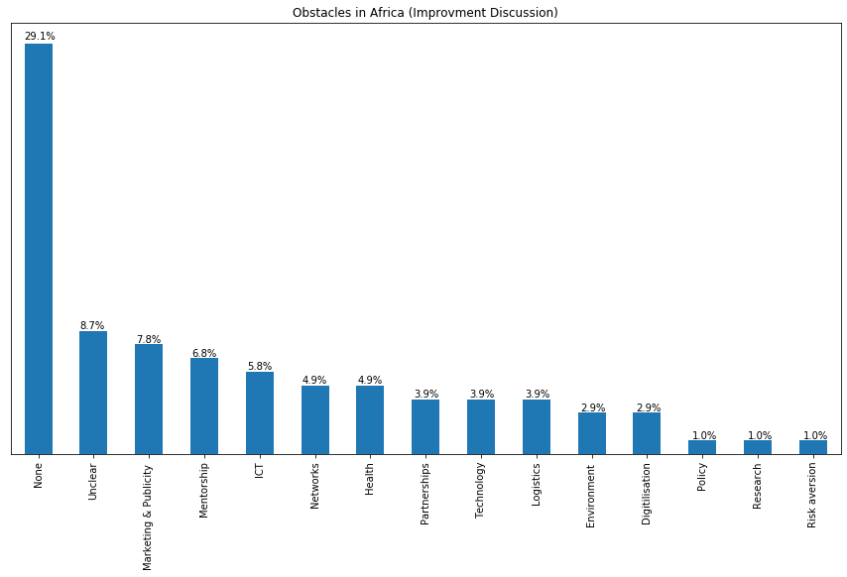

Question 2

How has virtualisation affected the following issues in the African Innovation Ecosystem

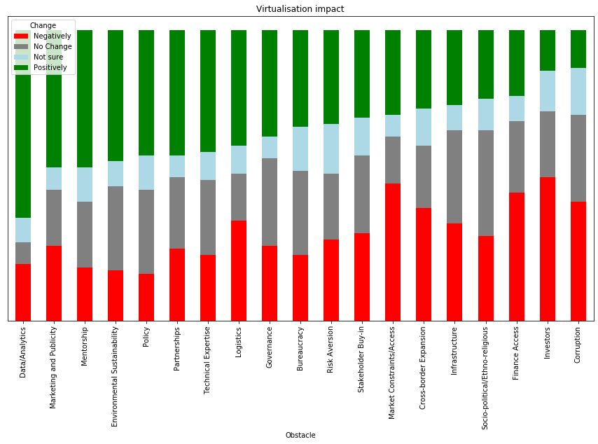

Question 3

Please give one or more examples of how your innovation practices (e.g. focus, activities, technologies, partnering, marketing, fundraising, etc.) have changed or evolved as a result of the COVID-19 pandemic. (Besides virtualisation)

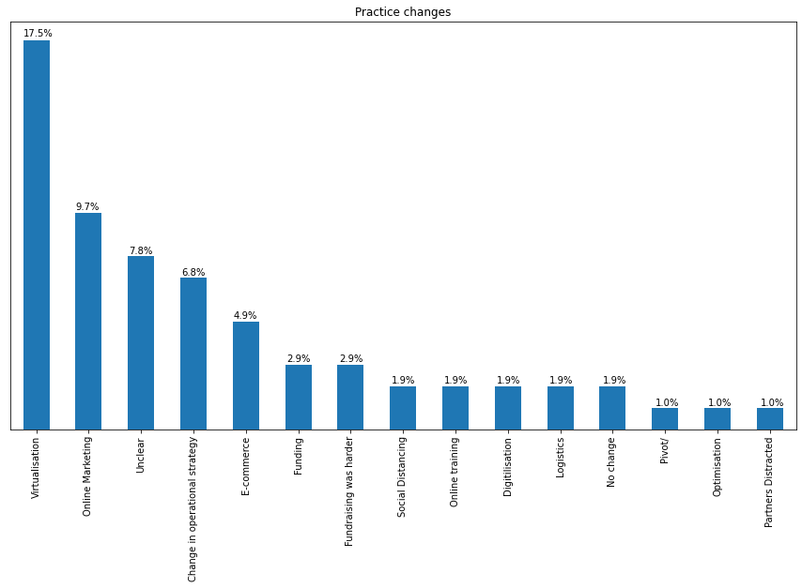

Question 4

Please list and briefly describe two recent government interventions or changes to policy or regulations affecting your innovation ecosystem which you consider to have been more impactful, and why

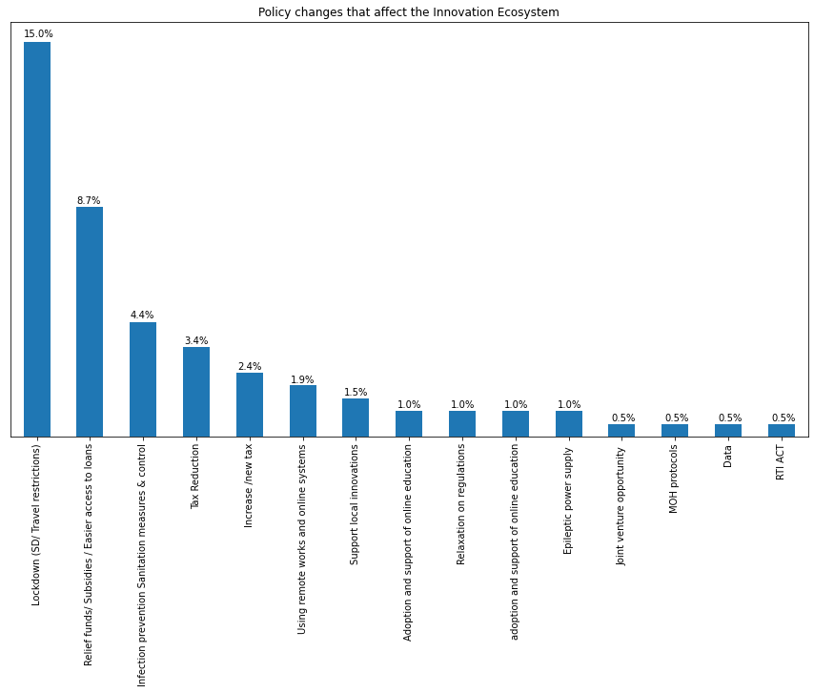

Question 5

Please discuss any policy recommendations, insights or comments that you may have that actors in the African innovation ecosystem may use to better adapt in the age of COVID-19.

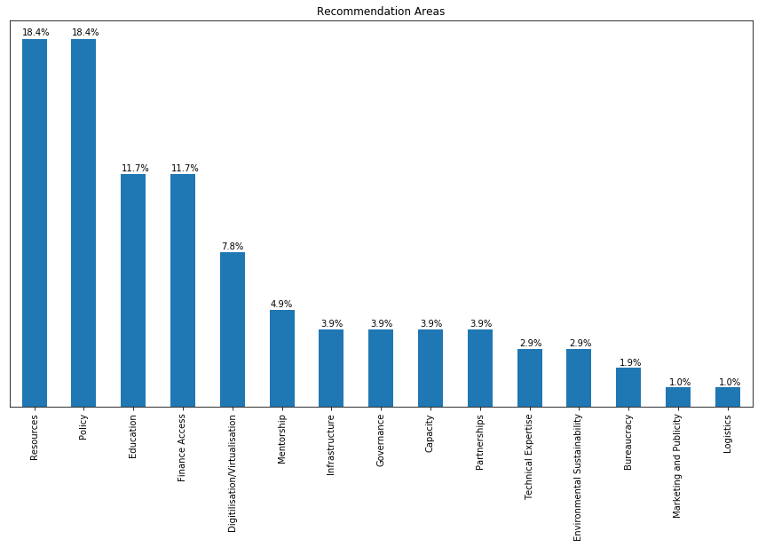

Please discuss any opportunities that you may have identified that can be leveraged by actors in the African innovation ecosystem in the age of COVID-19.

